# Interactive Demos for Amazon Redshift Course

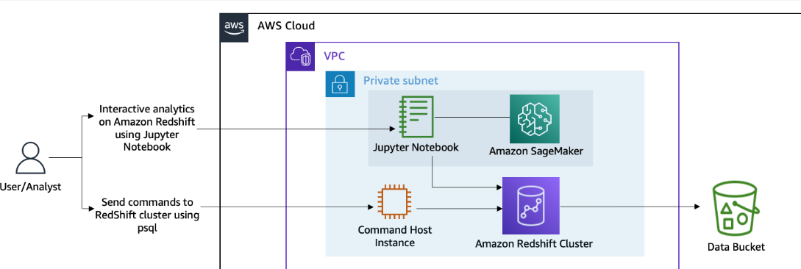

Demo 1 -

RS intro

Open redshift, and pre-built cluster

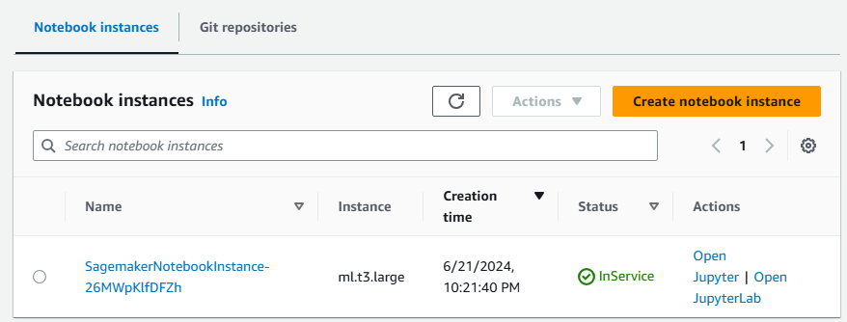

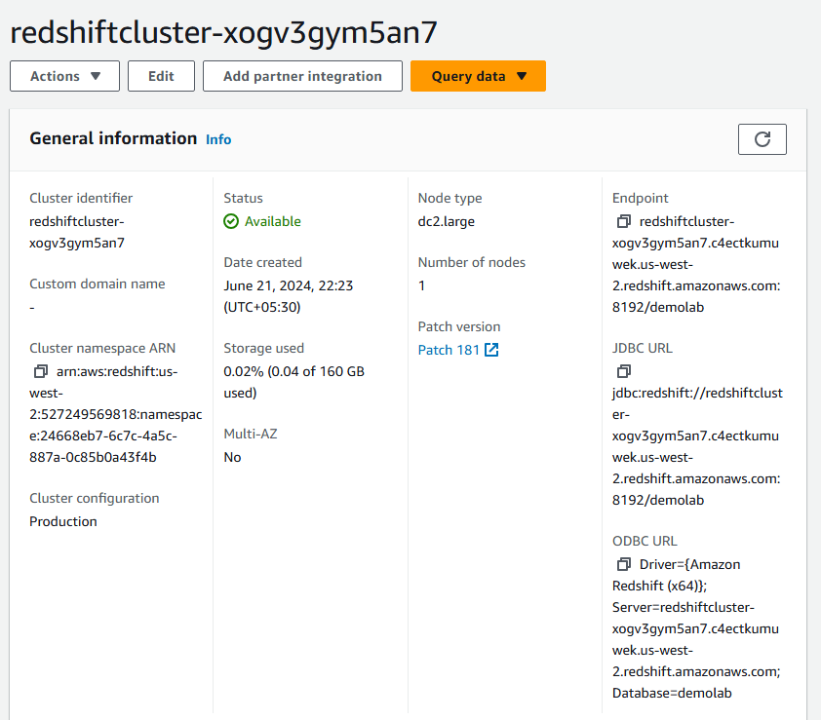

Notice

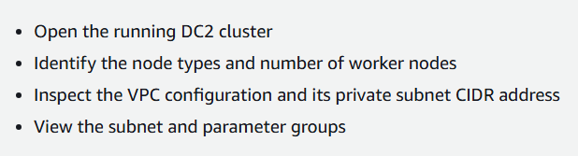

**Demo 2: Connecting your Amazon Redshift cluster using a Jupyter notebook with Data API**

**Objs-**

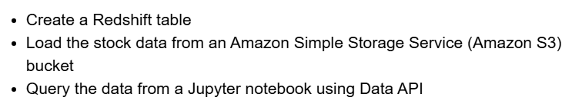



Open sagemaker, select this notebook

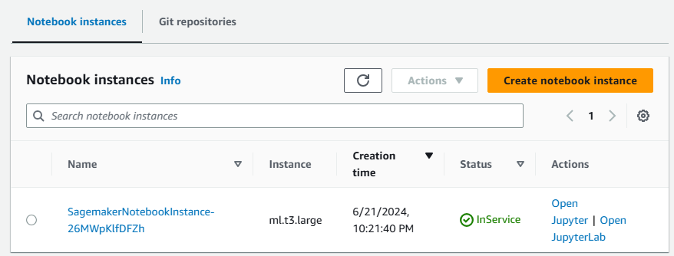

Get credentials;

Like below, we use python to get DB details from AWS secret manager

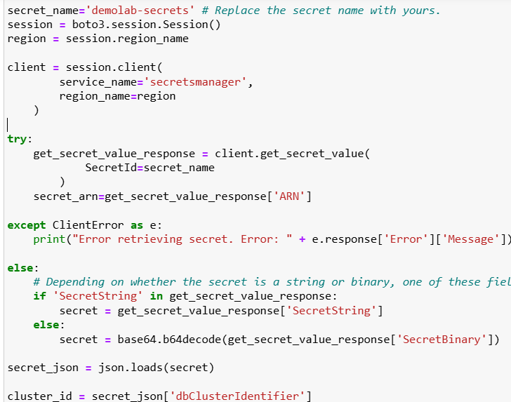

S3 file and API

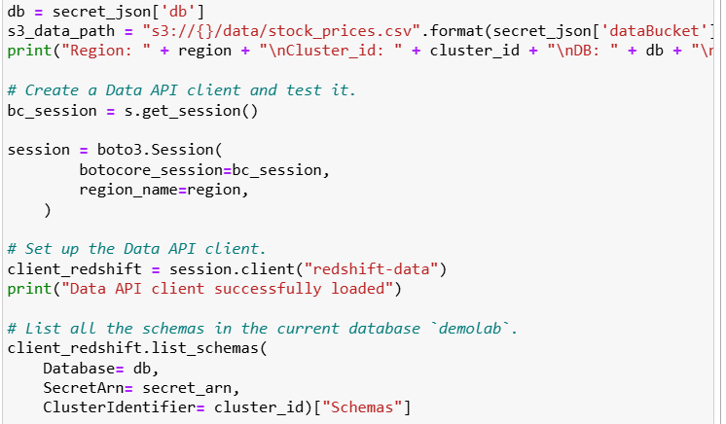

**Create a table schema and table**

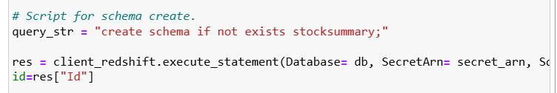



For table

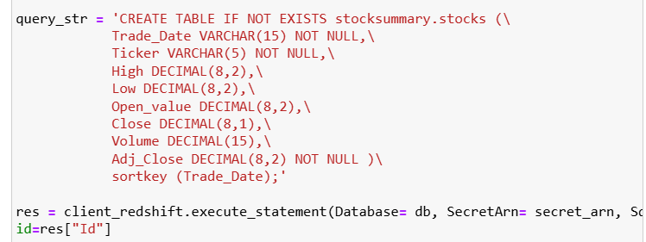

Data loading from s3 to table







op-

Querying from data



Had the code with connected “res” to “output”

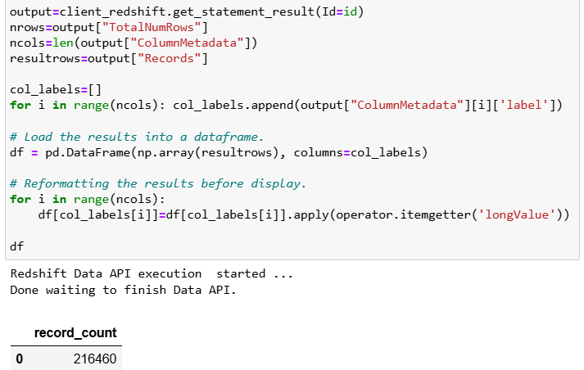

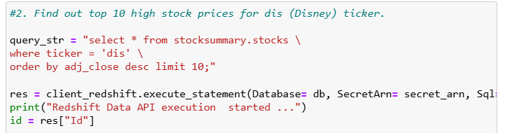

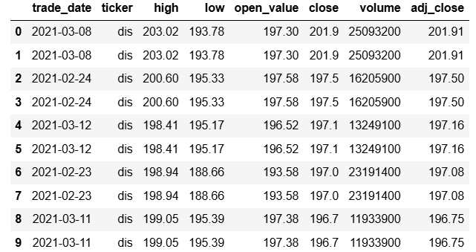

**In demo 3, we connect to RS using pgweb, and do WLM (lab 6, paid course, skipped)**

**Interactive Demo 4: Amazon Redshift cluster resizing from the dc2.large to ra3.xlplus cluster**

Open cluster

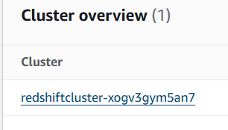

In actions

